Ross River Virus

Viral Diseases of Honeybees

Australian Bat Lyssavirus

BIOLOGY WA ATAR UNITS 3 & 4
Reading
Chapter 13 page 436 – 440

Questions
Set 13.3, page 450 Q 2

BIOZONE
83 Viral Diseases
86 Human Viral Diseases
87 Animal Viral Diseases

Topic Question | Notes
State the name of the disease and the name of the virus

Label the diagram of the enveloped virus  List the structural features of the virus | 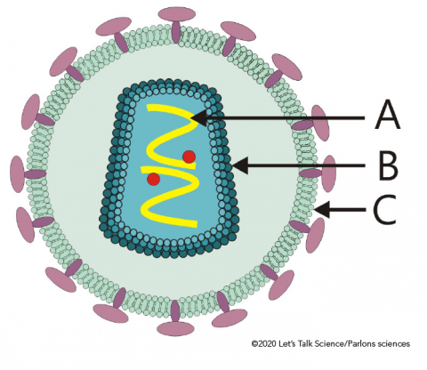
Ross river virus is endemic in Australia. Explain what this means

The mode of transmission is indirect via a vector. Define the term vector

State the name of the vector of Ross river virus and describe the vector

Define the term outbreak

Explain why Ross river virus outbreaks have coincided with high rainfall

Label the diagram of the life cycle of Ross River Virus | 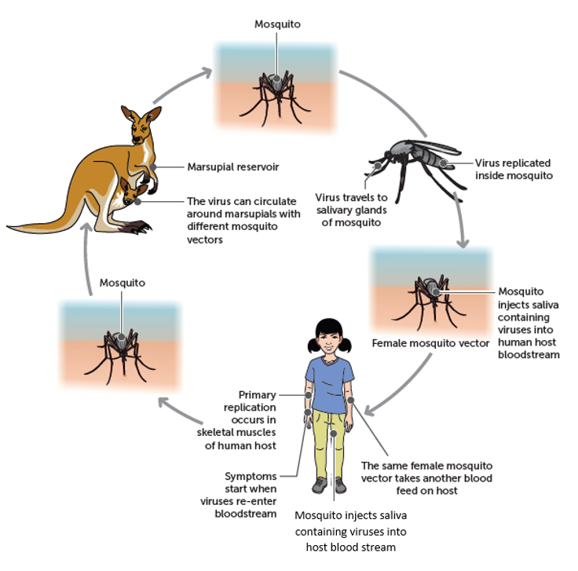
- State the mode of transmission of the virus

- Describe how the virus is spread of one host to another

- How does this mode of transmission influence the spread of RRV
Describe how the virus replicates. You can use a diagram

State the Incubation period of the virus. Show this on the graph  Describe the implications of this incubation period on the spread of the disease | 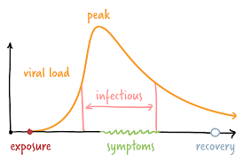
List the Symptoms of Infection and the impact of the disease on the host

State the Treatments used for RRV
Describe methods of Control for RRV

Topic Question | Notes
List the common viral diseases of Honeybees in Australia.

Of these viruses, which ones are found in WA?

Name of Disease | Sacbrood Disease
State the name of the virus and list the structural features of the virus
Describe the life cycle of the disease

Describe the life cycle of the disease

List the symptoms of infection the disease and the impact of the disease on the host
Name of Disease | Deformed Wing virus
State the name of the virus and list the structural features of the virus
Describe the life cycle of the disease

List the symptoms of infection the disease and the impact of the disease on the host | Read page 413 Biology WA ATAR Units 3 & 4
Name of Disease | Black Queen Cell Virus
State the name of the virus and list the structural features of the virus
Describe the life cycle of the disease

List the symptoms of infection the disease and the impact of the disease on the host | Read page 413 Biology WA ATAR Units 3 & 4
List any treatments available for the three diseases you have described above

Currently the Varroa mite is common in many countries outside of Australia. Outline measures that can be employed to reduce the mite becoming established in Australia
Outline the potential impact on the environment and the economy of viral diseases of Honey bees in Australia
Outline control measures to ensure Australia remains free of many viral diseases of Honey bees

Topic Question | Notes
State the name of the disease virus | Australian Bat Lyssavirus Disease
Label the diagram of the virus and list the structural features of the virus | 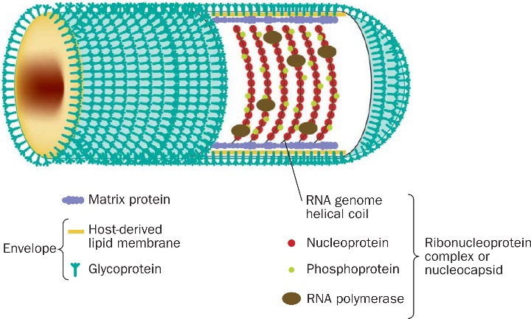
Describe symptoms of the disease in humans

Describe the symptoms of the disease in Bats | Read page 440 Biology WA ATAR Units 3 & 4
Why can ABL be described as a zoonotic disease?

Describe the life cycle of the virus causing ABL

State the mode of transmission and describe how it is transmitted
List the treatments available in Australia for ABL
Describe the control of this disease in Australia

Explain why ABL is a risk to human health

This is the how and why. How is it transmitted and how does it impact the host?

